Building Verdicts with the Glasnost Python Parser

By Hadi Asghari
May 2012.
The Network is Aware Project

Abstract
Glasnost is a test created by researchers at the Max Plank Institute and hosted on M-Lab that “enables ordinary Internet users to detect whether their ISPs are differentiating between ﬂows of speciﬁc applications”. In this document we discuss some of the challenges involved in parsing, analysing and interpreting the logs.

Project Background
Our research at the Network is Aware Project investigates the deployment and governance of deep packet inspection (DPI), a technology for monitoring and controlling Internet communications by network operators. DPI allows a network operator to recognize specific applications, or even specific items of content, as they flow through the network in real time, and then take actions based on that recognition. Those actions can be beneficial – e.g., recognizing and thwarting spam or malware – or politically controversial – e.g., rationing bandwidth, blocking access to censored content, or building user profiles for advertisers. With the dual potential to improve the operation and governance of the Internet and to restrict or regulate it in repressive ways, DPI use is being actively contested politically. Many operators have deployed it secretly, and some have even denied that it was being used after it was discovered. In broad terms, we wanted to find out what impact this new technological capability is having on the way the Internet is governed. That led to a set of more specific research questions:
- Which operators are using DPI to discriminate among applications and which are not?
- When they do discriminate, do they throttle or block, and do their policies affect uploads, downloads or both?
- How do operator practices respond to regulations and laws aimed at DPI or net neutrality?
One way to get this information is to ask the operators, but as a research method that is not really viable. There are thousands of different ASNs in the world and it would be costly and time consuming to survey all of them. Aside from that, the operators have nothing to gain by telling researchers about their technical policies and much to lose. And how would one know they were telling the truth? So an alternative strategy is for network users to run tests that reveal what is actually happening to their traffic.
A network test known as Glasnost was developed by researchers in Germany to detect blocking or throttling of BitTorrent and other peer to peer (P2P) file sharing protocols. The detailed workings of the Glasnost test are described in a paper by Dischinger, Marcon, et al. Thanks to an initiative known as the Measurement Lab (MLab), the Glasnost test was placed on a global platform so that end users all over the world could run the test and the results would be stored and made available to researchers. This way of crowdsourcing the generation of network performance data provides researchers with longitudinal data. An Internet user who runs the Glasnost test can see whether BitTorrent (or other protocols) is completely blocked, slowed down, or running unhindered. The results also allow us to infer whether the BitTorrent manipulation took place through DPI or through simpler port blocking.

Processing Glasnost data
The Glasnost client transfers data between the client and the Glasnost measurement servers, using both a random bit-stream and the BitTorrent protocol, on different TCP ports. It subsequently compares the transfer speed among these different application flows. Based on a set of criteria it determines whether the ISP is slowing down or blocking BitTorrent, and if so, whether discrimination is based on TCP port numbers or actual recognition of the BitTorrent protocol on any port. The latter, we infer, is only possible if DPI is being used. The servers log all test information along with the client’s IP address and the time of the test. Our initial impression was that these logs could be converted relatively easily into a dataset suitable for policy research. However, this turned out not to be the case, as we shall describe.

Level of aggregation
The Glasnost data is stored at the level of individual tests on Google Storage. For each test, a server log and a packet dump are stored. Only the log is of use in our work. All the logs for a single day and server are grouped into one compressed file and accessible via the gsutil tool. As stated, for each test we are interested in knowing whether it indicates BitTorrent throttling, blocking or neither. Although these results are calculated and shown to the user when they do the test, they are not stored in the logs. This makes it necessary to parse and analyse the logs and re-calculate this verdict. Based on our request to M-Lab, parsing and analysis scripts were provided for newer logs. Our Python Parser is partly based on these scripts, but further developed to decide verdicts and handle corner cases.

ASN & country-code lookups
A general step that need to be taken is mapping each test client’s IP address to its country and autonomous system. For the first purpose, we make use of the MaxMind GeoIP country database which provides good accuracy and historical versions going back for several years. For the second purpose, we use PyASN, a Python library developed by ourselves that performs fast IP to ASN lookups using historical RViews BGP data. The Python Parser performs these steps.

Consistency over time
The Glasnost data has several breaks in the logs. First, the log formats change: the 2008 data is available only as a CSV file by direct request from the authors; January 2009 to April 2010 tests use what we call the version 1 logs; and May 2010 onwards use the version 2 logs. The newer logs allow more protocols to be tested and added a “summary line” to the end of each log. There format changes did not create any particular statistical problems, but made parsing more complicated.
The second break, which has statistical relevance, is due to changes in the default Glasnost test parameters. The measurement duration, repetitions, and directions were changed during the test life. Prior to August 2009, the measurements were repeated twice and conducted in both directions. During August to October of that same year, the Glasnost project experimented with setting the test to use different repetitions, duplex and durations, to see which measurements would yield the fewest false positives and false negatives, yet not be so long as to bore the users into stopping the test. These changes create very visible jumps in the results’ percentages. (See Figure 2)
Table 1 – Glasnost log changes over time
Period | Log format | Protocol | Measure. repetitions | Test direction
04/2008– 01/2009 | CSV | BT | 2 | Both
02/2009-07/2009 | V1 | BT | 2 | Both
08/2009-10/2009 | V1 | BT | 2 to 5 | Single & Both
11/2009-04/2010 | V1 | BT | 3 | Both
05/2010– 02/2012 | V2 | Many (incl. BT) | 3 | Both
The third break which is that for several periods in 2010 and 2011, the longest of which spans several weeks (12-Oct-2010 and 25-Nov- 2010), no test logs exist. This was due to an unfortunate rsync problem between the M-Lab servers and Google Storage, the result of which has been the loss of data.

Turning logs to verdicts
Our need was to have a simple verdict for each test run: does it indicate the presence of application based throttling or blocking (hence, DPI), or not?
This turns out to be involved, for three reasons: (1) the test results that are shown to the end user are not stored in the logs; detailed information about each measurement flow is what is recorded; this necessitates reanalysis of the measurements; (2) the Glasnost server code that performs the analysis of the measurements does not calculate a combined judgement, but rather reports individual results for upload, download, throttling and blocking; the end-user herself deduces what this means, which in our case has to be done programmatically; (3) the data contains quite a number of corner cases and anomalies which further complicate matters, as we shall see.
We will have to start by giving a crash course on how the Glasnost test works. The client and server run a series of measurements in which they transfer bytes of data using different protocols (the application being tested versus a random bit-stream) and different TCP ports (the specific port assigned to the tested application versus a neutral port). The speed of each measurement is recorded, in addition to whether it was interrupted for some reason. Now, if we compare the speeds of these flows (listed in Table 2) and for instance discover that the speed of the application being tested is much slower than the speed of the control flow then we can conclude that the ISP is performing application-based throttling, as presumably the client’s link and the server’s link speeds remain the same. There is one caveat however: the Internet routes traffic on a ‘best-effort’ basis, which means that some speed fluctuations are to be expected. For this reason, certain thresholds have to be met: first, the flow speeds have to differ more than 20%; second, to make sure that the connection is not too noisy, each measurement is repeated three times, and these have to yield similar results (i.e., measurements of the same flow should have less than 20% difference). The choice of these thresholds is explained in the aforementioned paper by Dischinger and his colleagues. The simple comparison cases are illustrated in Table 3.
Table 2 - Glasnost measurement flows
Flow # | Direction | Port | Protocol
0 | upstream | app-port | application
1 | upstream | app-port | control-flow
2 | upstream | neutral-port | application
3 | upstream | neutral-port | control-flow
4 | downstream | app-port | application
5 | downstream | app-port | control-flow
6 | downstream | neutral-port | application
7 | downstream | neutral-port | control-flow

The cases get more complicated when considering noisy flows, and also a condition known as broken measurement. A broken measurement is when either the transfer does not start (duration is zero) or it starts but no data is transferred (bytes transferred is zero). This is indicative of some form of network blocking and if it happens more than once on a particular flow, we consider that flow as failed and cannot use it for speed comparisons (all is not lost, however, for depending on which port the flow occurs on, some judgements can be made.)
Table 3 – Detection of throttling (simplified)
Interim | Comparison | Meaning
AD1 | app-flow on app-port  << control-flow on app-port | App-based throttling
AD2 | app-flow on neutral-port  << control-flow on neutral-port | App-based throttling
PD1 | app-flow on app-port  << app-flow on neutral-port | Port-based throttling
PD2 | control-flow on app-port  << control-flow on neutral-port | Port-based throttling
If we take into account the noisy and failed flows, we end up with the Table 4 to detect app-based throttling. A similar table can be drawn for port-based throttling, and both sub-verdicts can be made for both the upstream and downstream directions.
Table 4 - Detection of app-based throttling IN detail
AD1-comparison | AD2-comparison | App-based throttling?
af-ap or cf-ap  is noisy or broken | af-np or cf-np  is noisy or broken | too noisy to tell
af-ap << cf-ap | af-np << cf-np | Y
af-ap << cf-ap | noisy or broken | Y
af-ap << cf-ap | af-np >= cf-np | Y, with warning*
noisy or broken | af-np << cf-np | Y
af-ap >= cf-ap | af-np << cf-np | Y, with warning*
af-ap >= cf-ap | af-np >= cf-np | N
af-ap >= cf-ap | noisy or broken | N
noisy or broken | af-np >= cf-np | N
* this is the strangediff warning explained later
legend: af-ap = app-flow on app-port, etc.
The next step in the analysis is deciding on the meaning of failed flows. A flow fails when either a TCP-RST packet is seen during the measurement that was neither sent by the server or the client, or when no data is transferred at all (the measurement is broken) for at least two out of the three repetitions. Different combinations of flows might fail, and the implication will differ based on the combination. Should the control-flow on the neutral port fail, this is for sure indicative of a noisy measurement or some other form of malfunction, as there is never any basis for this flow to be blocked. The remaining combinations are listed in Table 5.
Table 5 – Possible combinations of failed flows
af-ap | af-np | cf-ap | Block mechanism
blocked | blocked | blocked | dpi-based & port-based
blocked | blocked | ok | dpi-based
blocked | ok | blocked | port-based
blocked | ok | ok | dpi-based ?
ok | blocked | blocked | noisy (undefined combi.)
ok | blocked | ok | noisy (undefined combi.) ?
ok | ok | blocked | noisy (undefined combi.)
ok | ok | ok | ----
At this stage we have created several sub-verdicts that need to be combined into a final grand verdict for the test at hand. This is done in Table 6. The verdict DPI means that the test indicates DPI-based throttling or blocking is being performed by the ISP; PORT indicates PORT-based throttling or blocking is occurring; UNDEF means that the result is undefined -- due to noise we cannot deduce anything from this test; OK means that the test could not detect any form of traffic manipulation; and finally, OK1/2 cases are where the result is most likely OK but could also be other things.
Table 6 - Calculating a Test’s final verdict
App-based throttling | Port-based throttling | Block mechanism | Test verdict | N+
throt | * | * | DPI | 12
ok | * | dpi | DPI | 3
noisy | * | dpi | DPI | 3
ok/noisy | throt | port/noisy/--- | PORT | 6
ok/noisy | ok/noisy | port | PORT | 4
ok/noisy | ok/noisy | noisy | UNDEF | 4
noisy | noisy | --- | UNDEF | 1
ok | noisy | --- | OK1/2 | 1
noisy | ok | --- | OK1/2 | 1
ok | ok | --- | OK | 1
 |  |  |  | 36
+Number of combinations
Table 6 shows results for a single direction. ‌The verdict for both directions is calculated similarly. The exception is for unidirectional tests, where if the overall verdict is OK, it is changed to UNDEF, as we do not have any information on the other direction and all verdicts are possible outcomes.
Please note that these are all based on completed tests. In reality, many Glasnost tests never finish and/or are aborted mid-way; for such tests the analysis step is skipped all together. The originally provided Glasnost analysis scripts only conduct simple comparisons and the more involved steps had to be developed by us.

Strange and anomalous cases
In the Glasnost data there are quite a number of logs that we can only classify as odd – they might be indicative of corner cases, misconfigurations of the user’s machine, or unstable network conditions. These are listed and explained in Table 7. We flag these cases in our database and in most cases take no further action.
Table 7 – Warning flags for various odd measurements
Flag | Explanation | %*
btfaster | The BitTorrent flows are significantly faster than the random flows!! Why would an ISP do this? | 14%
cfnpfail | The random bit-stream on the neutral port is blocked! On what basis should this happen? | 6%
strangediff | In app-based throttling, one of AD1 or AD2 indicates throttling while the other indicates its absence, which doesn’t make sense! (Same for port-based) | 9%
portchange | The application specific port was changed in the middle of the test (this sometimes happens). If the final verdict was PORT, we change it to UNDEF. | 1%
* percentage of completed tests with this flag set
A point that we briefly made in the previous section was many tests are aborted midway by impatient users. In our own tests that we performed at the Syracuse campus we however discovered a strange caveat: the Glasnost server was logging our tests as aborted after the first flow, whereas we had patiently waited for its completion. Syracuse campus uses a DPI device to block all P2P traffic, both based on application signature and TCP port number. In correspondence, the Glasnost authors clarified that when the port is outright blocked and the TCP handshake cannot complete, the server assumes the user has aborted test after a certain timeout. It is unclear to us however what the difference is between this form of aborted test and instances where the test completes but certain flows fail (as indicated in Table 5), and our follow up questions to the test authors yielded no satisfactory explanation. What worries us most is that 9,000 of the tests that are thrown out as anomalies both in our scripts and in the original Glasnost analysis scripts follow this pattern (aborted after one flow with and a runtime of approx. 50 seconds). These would in fact make some of the interesting cases indicative of ISP manipulation. Further research is recommended on this issue.

Issues with sample size
Although we cannot really blame any crowd-sourced measurement project for inadequate sample size in specific observation groups, methods can be thought of to remediate such a problem.
Two specific problems of sample size exist in the Glasnost data. First, although the test has supported testing many different protocols since May 2010, BitTorrent still makes up the vast majority of the tests (see Figure 1). The reason is clear: BitTorrent is selected as the default choice of the test interface. This is obviously a pity and might be remediated by the Glasnost test site setting different defaults for different visitors.

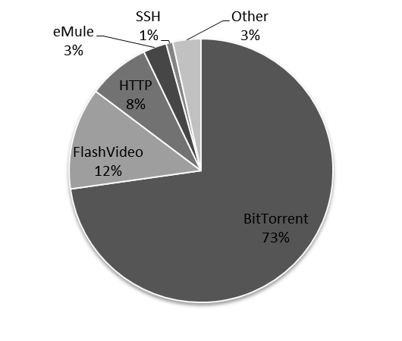
Figure 1 - Completed Tests by protocol (n≈109,000) – May 2010-Feb 2012
A serious sampling problem also exists for ASNs with 10 or less tests per time period. In such ASNs, extreme variation in the results – at times oscillating from 0% to 50% - is seen. This is easy to understand, as due to the low number of tests one positive result added or removed makes a large difference. One remedy would be similar but at a broader level: the M-Lab website should recommend users to run the Glasnost test when the total number of tests from that ASN is low.

The “cleaned” dataset
At this point and after much work to download, parse, fully understand and analyse the raw Glasnost logs, we have our “cleaned” dataset - one that is ready for econometric analysis.
This dataset contains approximately 326,000 completed tests for the period 2009 – 2011. These tests were run by users of approximately 1,400 ASNs located in approximately 100 countries. In the last quarter of 2011 and the first two months of 2012, we have about 32,000 tests with only 35 countries and 353 ASNs with adequate sample size. The completed tests account for around 40% of the total Glasnost logs; in other words, 60% of the tests had to be thrown out as invalid.
Figure 2 shows how the test verdict percentages change over time. When we look at the data at the global world-wide level, it seems relatively stable. However, when we open up the data and look at it at the level of individual countries or ASNs, we see large changes in these patterns depending on specific circumstances. Overall, around a third of the completed tests indicate noisy as the result of at least one of their sub-verdicts, although a lower limit in the end stays undefined.
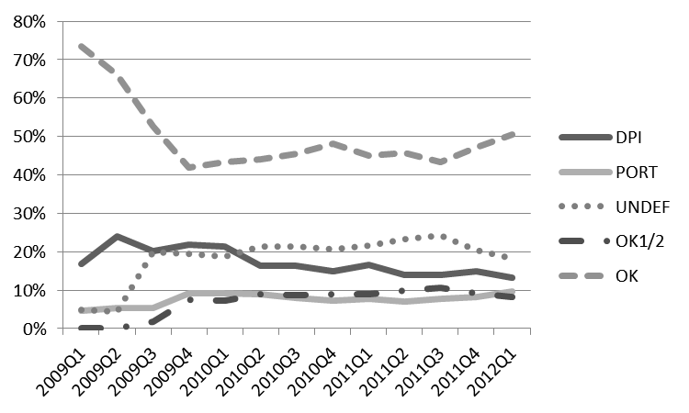
Figure 2 - Test verdict percentages over time

http://dpi.ischool.s yr.edu/Home.html
M. Dischinger, M. Marcon, S. Guha, K. Gummadi, R. Mahajan, and S. Saroiu, "Glasnost: Enabling End Users to Detect Trafﬁc Differentiation," 2010. Available online: http://research.microsoft.com/en-us/um/people/ssaroiu/publications/nsdi/2010/glasnost.pdf
gsutil cp gs://m-lab/glasnost/YYYY/MM/* .
http://www.maxmind.com/en/country
http://code.google.com/p/pyasn/
This combination might indicate very restrictive firewalling.
These might be as yet undiagnosed cases.
Counting countries with >100 tests and ASNs with >20 test

